ICEngineSoft Test Report

Report Date : Tue, Apr 19, 2022 , Time : 9:21:52 PM
Organization : Organisation, Operator : Operator
Data File : 19-04 Diesel.xlsx, Last Modified Date: Tue, Apr 19, 2022,
Config. File : Kirloskar TV1 Engine.xls

Engine Details :

ICEngine set up under test is Kirloskar TV1 having power 5.20 kW @ 1500 rpm which is 1 Cylinder, Four stroke , Constant Speed, Water Cooled, Diesel Engine, with Cylinder Bore 87.50(mm), Stroke Length 110.00(mm), Connecting Rod length 234.00(mm), Compression Ratio 17.50, Swept volume 661.45 (cc)

Combustion Parameters :

Specific Gas Const (kJ/kgK) : 1.00, Air Density (kg/m^3) : 1.17, Adiabatic Index : 1.41, Polytrophic Index : 1.10, Number Of Cycles : 10, Cylinder Pressure Referance : 6, Smoothing 2, TDC Reference :-1

Performance Parameters :

Orifice Diameter (mm) : 20.00, Orifice Coeff. Of Discharge : 0.60, Dynamometer Arm Legnth (mm) : 185, Fuel Pipe dia (mm) : 12.40, Ambient Temp. (Deg C) : 27, Pulses Per revolution : 360, Fuel Type : Diesel, Fuel Density (Kg/m^3) : 830, Calorific Value Of Fuel (kj/kg) : 42500

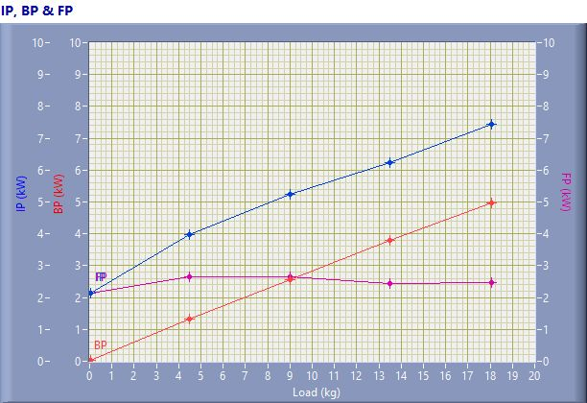

IP, BP & FP

Speed (rpm) | Load (kg) | IP (kW) | BP (kW) | FP (kW)
1580.00 | 0.06 | 2.15 | 0.02 | 2.14
1538.00 | 4.50 | 3.98 | 1.32 | 2.66
1501.00 | 9.02 | 5.23 | 2.57 | 2.66
1474.00 | 13.50 | 6.24 | 3.78 | 2.45
1450.00 | 18.06 | 7.44 | 4.98 | 2.46

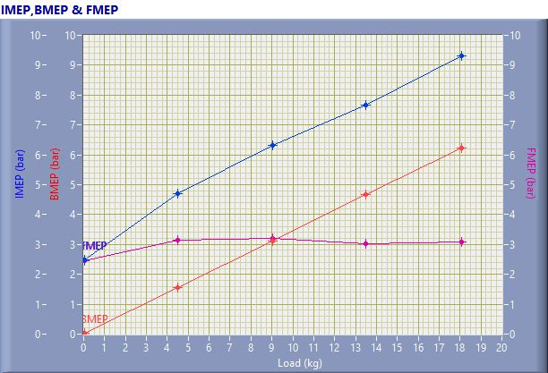

IMEP,BMEP & FMEP

Speed (rpm) | Load (kg) | IMEP (bar) | BMEP (bar) | FMEP (bar)
1580.00 | 0.06 | 2.47 | 0.02 | 2.45
1538.00 | 4.50 | 4.69 | 1.55 | 3.14
1501.00 | 9.02 | 6.32 | 3.11 | 3.21
1474.00 | 13.50 | 7.68 | 4.66 | 3.02
1450.00 | 18.06 | 9.31 | 6.23 | 3.08

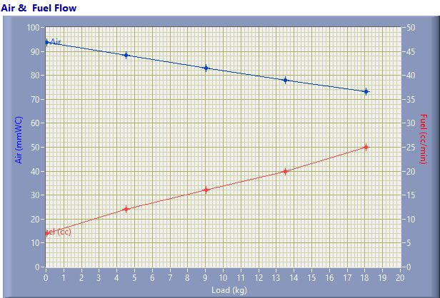

Air & Fuel Flow

Speed (rpm) | Load (kg) | Air (mmWC) | Fuel (cc/min)
1580.00 | 0.06 | 93.67 | 7.00
1538.00 | 4.50 | 88.44 | 12.00
1501.00 | 9.02 | 82.93 | 16.00
1474.00 | 13.50 | 78.05 | 20.00
1450.00 | 18.06 | 73.24 | 25.00

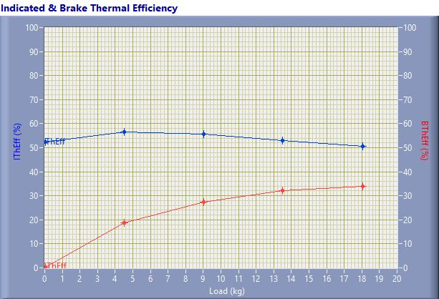

Indicated & Brake Thermal Efficiency

Speed (rpm) | Load (kg) | IThEff (%) | BThEff (%)
1580.00 | 0.06 | 52.31 | 0.41
1538.00 | 4.50 | 56.42 | 18.65
1501.00 | 9.02 | 55.63 | 27.36
1474.00 | 13.50 | 53.05 | 32.17
1450.00 | 18.06 | 50.63 | 33.86

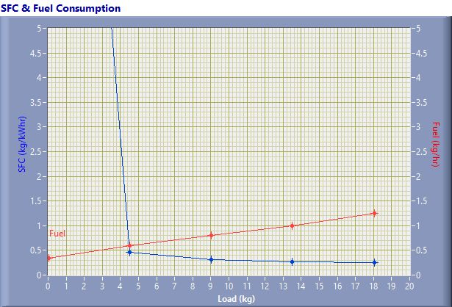

SFC & Fuel Consumption

Speed (rpm) | Load (kg) | SFC (kg/kWh) | Fuel (kg/h)
1580.00 | 0.06 | 20.73 | 0.35
1538.00 | 4.50 | 0.45 | 0.60
1501.00 | 9.02 | 0.31 | 0.80
1474.00 | 13.50 | 0.26 | 1.00
1450.00 | 18.06 | 0.25 | 1.25

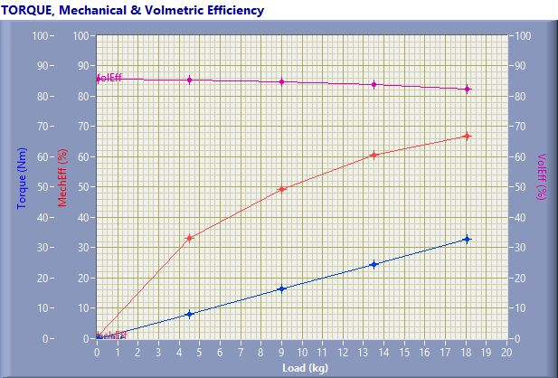

TORQUE, Mechanical & Volmertic Efficiency

Speed (rpm) | Load (Kg) | Torque (Nm) | Mech Eff. (%) | Vol Eff. (%)
1580.00 | 0.06 | 0.10 | 0.78 | 85.64
1538.00 | 4.50 | 8.17 | 33.06 | 85.49
1501.00 | 9.02 | 16.37 | 49.18 | 84.82
1474.00 | 13.50 | 24.51 | 60.65 | 83.79
1450.00 | 18.06 | 32.78 | 66.89 | 82.51

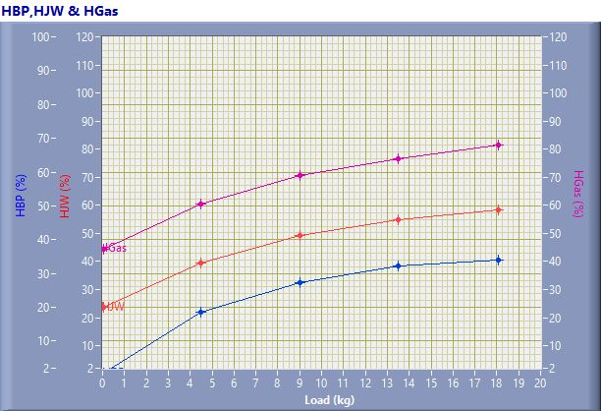

HBP,HJW & HGas

Speed (rpm) | Load (kg) | HBP (%) | HJW (%) | HGas (%) | HRad (%)
1580.00 | 0.06 | 0.41 | 23.14 | 20.86 | 55.60
1538.00 | 4.50 | 18.65 | 20.65 | 21.14 | 39.55
1501.00 | 9.02 | 27.36 | 21.80 | 21.35 | 29.50
1474.00 | 13.50 | 32.17 | 22.64 | 21.71 | 23.48
1450.00 | 18.06 | 33.86 | 24.53 | 22.97 | 18.63

Observation Data

Speed (rpm) | Load (kg) | Comp Ratio | T1 (deg C) | T2 (deg C) | T3 (deg C) | T4 (deg C) | T5 (deg C) | T6 (deg C)
1580 | 0.06 | 17.50 | 43.89 | 49.33 | 43.89 | 42.47 | 115.16 | 97.44
1538 | 4.50 | 17.50 | 43.98 | 52.31 | 43.99 | 43.27 | 183.33 | 145.32
1501 | 9.02 | 17.50 | 44.04 | 55.76 | 44.05 | 45.05 | 242.80 | 189.06
1474 | 13.50 | 17.50 | 44.13 | 59.34 | 44.13 | 47.38 | 307.69 | 238.09
1450 | 18.06 | 17.50 | 44.19 | 64.80 | 44.19 | 51.25 | 406.52 | 307.88

Observation Data

Air (mmWC) | Fuel (cc/min) | WaterFlow Engine (lph) | WaterFlow Cal (lph)
93.67 | 7.00 | 150 | 75
88.44 | 12.00 | 150 | 75
82.93 | 16.00 | 150 | 75
78.05 | 20.00 | 150 | 75
73.24 | 25.00 | 150 | 75

Result Data

Torque (Nm) | BP (kW) | FP (kW) | IP (kW) | BMEP (bar) | IMEP (bar) | BTHE (%) | ITHE (%) | Mech Eff. (%)
0.10 | 0.02 | 2.14 | 2.15 | 0.02 | 2.47 | 0.41 | 52.31 | 0.78
8.17 | 1.32 | 2.66 | 3.98 | 1.55 | 4.69 | 18.65 | 56.42 | 33.06
16.37 | 2.57 | 2.66 | 5.23 | 3.11 | 6.32 | 27.36 | 55.63 | 49.18
24.51 | 3.78 | 2.45 | 6.24 | 4.66 | 7.68 | 32.17 | 53.05 | 60.65
32.78 | 4.98 | 2.46 | 7.44 | 6.23 | 9.31 | 33.86 | 50.63 | 66.89

Result Data

Air Flow (kg/h) | Fuel Flow (kg/h) | SFC (kg/kWh) | Vol Eff. (%) | A/F Ratio | HBP (%) | HJW (%) | HGas (%) | HRad (%)
31.52 | 0.35 | 20.73 | 85.64 | 90.41 | 0.41 | 23.14 | 20.86 | 55.60
30.63 | 0.60 | 0.45 | 85.49 | 51.25 | 18.65 | 20.65 | 21.14 | 39.55
29.66 | 0.80 | 0.31 | 84.82 | 37.22 | 27.36 | 21.80 | 21.35 | 29.50
28.77 | 1.00 | 0.26 | 83.79 | 28.89 | 32.17 | 22.64 | 21.71 | 23.48
27.87 | 1.25 | 0.25 | 82.51 | 22.39 | 33.86 | 24.53 | 22.97 | 18.63

